CSE-4410 Programming Assignment 1

**Part 1** (20 points) – Follow the roll-a-ball tutorial. (You don’t have to build the game.) To show that your game works, rather than submit the entire project, you’ll need to submit the following:

* A screenshot of the beginning of the game.

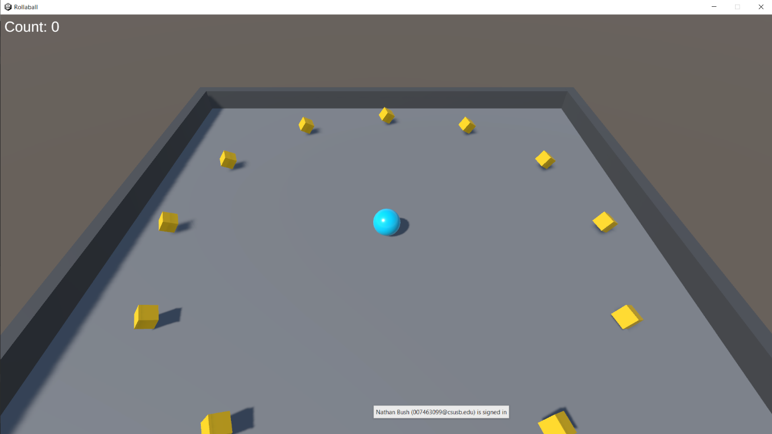

* A screenshot of the player picking up one of the cubes.

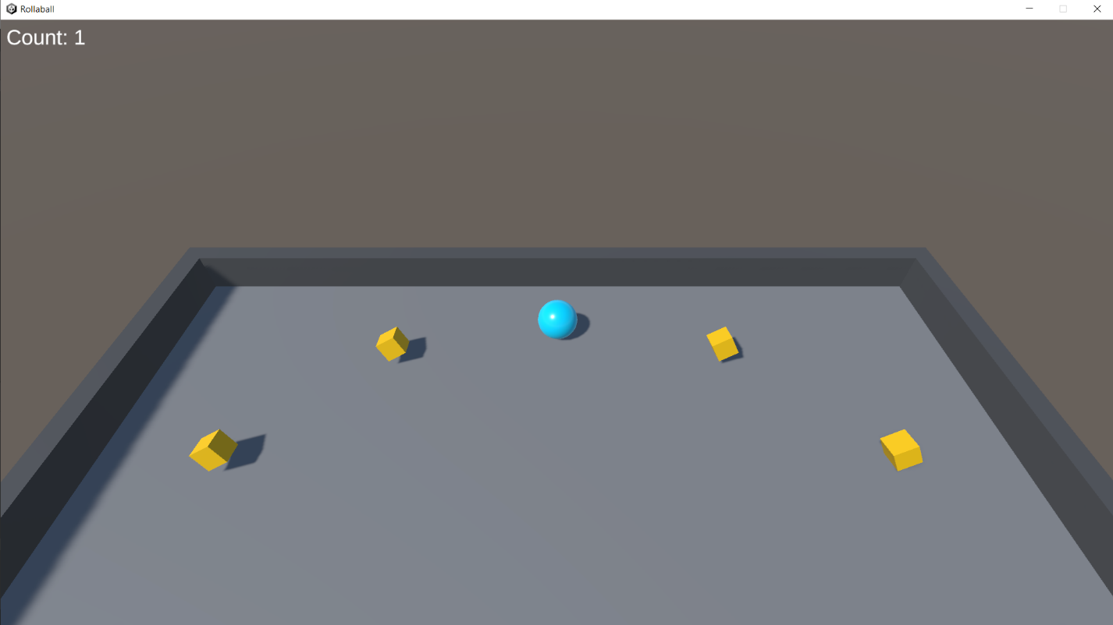

* A screenshot of winning the game.

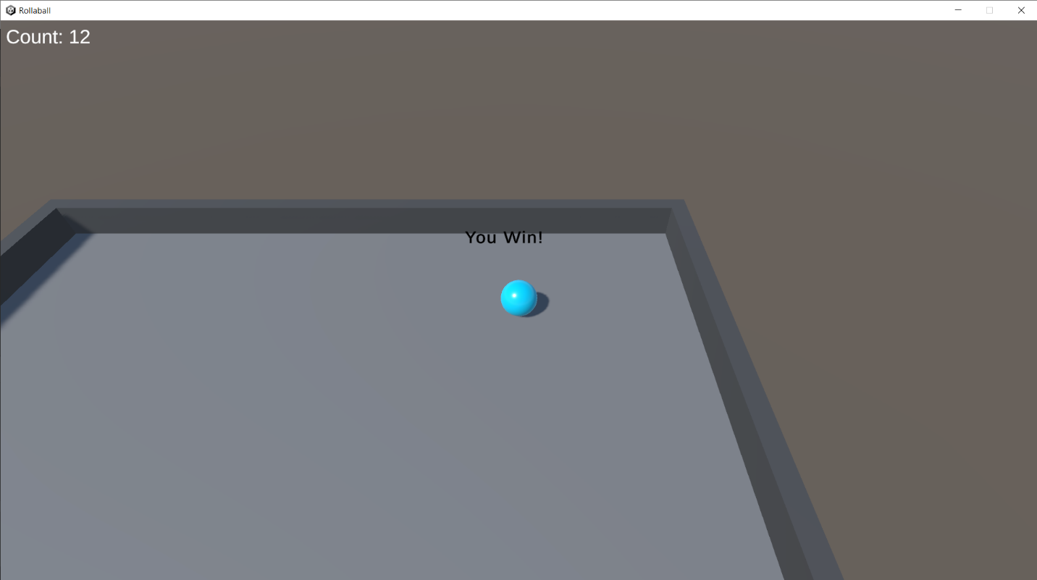

**Part 2** (30 points) – Modify the game any way you see fit! You can add additional functionality to the game or modify the play area to include more features, such as (but not limited to):

Changes made to extend the Roll a Ball game:

* Added ambient background music
* Added sound effect when pickup is triggered
* Pickup objects were modified to be more metallic and shiny.
* Modified the walls to have holes in the middle
* Made the walls have a rebound effect that reverses the ball’s direction and applies a force
* Added a sound effect to the rebound effect from walls
* Limited the ball’s maximum speed so the rebound effect could not exponentially apply force until the ball broke through walls
* Added an animated lava layer below the stage, where the game ends when the player hits the lava
* Added a “Lava Death” message on falling in lava
* Added an explosion particle system that detaches from the player at the point of lava impact and plays on death

All modified script files will be uploaded with this document. I will not be uploading the sound effect and music files, or the script that provides lava animation as that came built-in with a free lava prefab from the Unity Asset Store (UAS). All sound effects and background music were found on the UAS as well for free.

After modifying my program, I realized that many of my changes (music, sound effects, rebound) would not be adequately captured by screenshot. I’ve included a screenshot showing the new scene layout at game start, and one that shows the explosion particle system and death message when falling in lava.

